Temasek Polytechnic
School of Informatics and IT

Diploma in Information Technology (IT)

Software Requirement Specifications (SRS)

Project Particulars

Tutor | Dr Chia Chaw Poh
Class | P03
Project Title | Delonix Regia Hotel Management System

Project Team’s Particulars

Matric Number | Student Name
1301213c | Wong Sze Siang
1302677h | Kee Yun Mei
1300185d | Gan Kai Xian

Revision History

Date | Version | Description | Author
13/5/15 | 1 | Added Overview of Requirements | Wong Sze Siang  Gan Kai Xian
15/5/15 | 2 | Added Operation and Quality Requirements | Kee Yun Mei
19/5/15 | 3 | Added Special Requirement | ALL

Table of Contents

1. DISTRIBUTION OF WORKLOAD 4
2. OVERVIEW OF REQUIREMENTS 4
2.1 System Functions 4
2.2 User Characteristics 4
2.3 General Constraints 5
2.4 Functional Requirements 6
2.5 Data Requirements 7
2.6 User Interface Requirements 8
2.7 Interface with Other Systems 10
2.8 Assumptions 10
3 OPERATIONAL AND QUALITY REQUIREMENTS 11
3.1 Operating Environment 11
3.2 Development Constraints 11
3.3 Performance 12
3.4 Availability 14
3.5 Security and Access Control Requirements 14
4 SPECIAL REQUIREMENTS 15
5 REFERENCES 15

DISTRIBUTION OF WORKLOAD

Requirement Gathering | Members
User Interface, Interface with other systems, Assumptions, Operating Environment, Special Requirements | Wong Sze Siang
Development Constraints, Performance, Availability, Security and Access Control Constraints | Kee Yun Mei
System Functions, User Characteristics, General Constraints, Functional Requirements, Data Requirements | Gan Kai Xian

OVERVIEW OF REQUIREMENTS

System Functions
The functions of the system dictate what the users are going to be using the system for. Mr. Wang has highlighted in the interview that there are three main functions that the system will have. The functions are:

- Room availability and booking module – this function basically shows the rooms that are available for booking. Additionally, it also has a function to book the room that is available.
- Housekeeping and staff management module – this function serves as a roster or duty list that can be viewed and edited. It also has information of the staffs that is working in the hotel.
- Reporting module – this function generates various reports regarding the rooms that the hotel management and staff can use.

The three mentioned functions are the main functions that were discussed in the interview that Mr. Wang felt should be included into the system. Mr. Wang has also noted that other functions can be implemented as well, although not a priority.

User Characteristics
Mr. Wang has highlighted in the interview that there are three main user groups that will be using the system.

End users
The end users of the system include staffs of the hotel, such as the receptionist, and also the customers. The staffs will be able to access the room availability and booking function where they can edit a room information or make check outs. They will also have access to some of the reporting module so that they can view information about the rooms when the guests arrive at the reception area. The customers are another group of user that will have access to the room availability and booking module to view and book rooms that are available.

Management users
The management users are such as managers who are able access all the three main functions. The management users will be able do much more such as to view and edit bookings, view and edit staff rosters and access to various hotel reports. The management users will have most of the features of the system which is why the users are either managers or they are of a higher position.

Administrators
The administrators are such as Mr. Wang, who will have full access to all the three main functions of the system. In addition, the administrator will be able to create an account for the staffs in the hotel and have access to information of the accounts which can be edited as well.

The above three main user groups are what Mr. Wang has noted in the interview and mentioned what these users will be using the system for.

General Constraints
There are some constraints that were noted by us during the interview with Mr. Wang. Mr. Wang mentioned that the system will be installed on a legacy computer, Windows XP SP2 with Pentium 4, which could pose some compatibility or integration issues. The software and features that we are implementing might not be compatible with the software of the computer. The internet broadband connection that Mr. Wang currently has, might pose latency issues as well in regards to connection with the system and the customer.

The minor constraint is the backups are kept for 5 years and done only at a certain time frame. Due to the operating hours of the hotel, backups can only be done from 2-3am on the first Sunday of every month but not on a daily or weekly basis.

There will not be any integration with other systems as mentioned in the interview with Mr. Wang, that it is not the priority for now due to short development time frame.

There are no other legal or company constraints noted and the above mentioned are currently the constraints of building the system.

Functional Requirements
As discussed in the interview, each main function has its own set of operations and role that are carried out. These role or operations are stated as below:

Room availability and booking module
- This function should allow guests to search for rooms that are available base on either the type of room or the date that they are checking in for.
- The booking operation should accept data such as, last name, first name, number of adult and children, contact detail hand phone or email address, home address, payment details such as credit card or cash, check in date and time, check out date and time, additional remarks and accept late check-in.
- The receptionist and Mr. Wang will also be able to access and edit guest record e.g. change of room or adding additional guests.
- Payment invoice can also be generated with the information of number of days stayed, any items in the room consumed, guest details, check in and out date, number of nights stayed, room rates, any additional cost and payment mode.

Housekeeping and staff management module
- Allows administrators to create staff account with information such as name, date of birthday, bank account, home address, phone number and the duty assigned which is either general maintenance, room maintenance, estate maintenance or security.
- Management and Administrators will be able to edit information of staff account, view and assign duties.
- Staff will be able to login and view their duties that have been assigned to them accordingly.

Reporting module
- Able to generate 5 different reports namely room status, all guest in one room, all guest and room at a certain date, room occupancy and housekeeping.
- Room status report will list all the rooms in the hotel their respective room status such as vacant, occupied or vacant scheduled for cleaning.
- All guest in one room report will list all the occupants that are staying in the room e.g. 2 adults 3 children.
- All guest and room at a certain date report will list out all guest and rooms on any day e.g. list from 15 January 2015 will show all the guests that are staying on that day and their room.
- Room occupancy report will generate statistics of the room occupancy on a daily, weekly, monthly and yearly basis. The statistics will include total number of guest stayed in the room and total guest that stay at the hotel according to when the report is generated.
- Housekeeping report will list the duties that the staffs have been allocated to and housekeeping schedule will be generated on a daily, weekly or monthly basis.
- Staffs will only be able to view room status report, all guests in one room report and all guest and room at a certain date report.
- Management and administrators will have full access to all 5 reports.
- Reports are printable and can be previewed before printing.

The above mentioned are the operations of each of the main functions of the system.

Data Requirements
The data that are going to be inserted into the system has also been identified through the interview with Mr. Wang. Here are the tables that are going to be developed:

Booking
This table will take in most of the information from the customer for booking of a room. The basic data that are stored in here are such as name, number of guests, contact and address. This is the table that will be used frequently as bookings are created, edited or deleted.

Check In Out
This table shows the check in date and time of the customer that has booked a room and also the checkout date and time too.

Book Detail
This table basically shows which room is assigned to the customer that booked it. There might be multiple same booking ids with different room numbers since in a single booking there could be many of guests staying at the hotel.

Room
This table will feature all the rooms in the hotel and their current status. This allows easy checking for vacancy of rooms. The information that is stored in this table are such as the room number, the floor and the status of the room.

Payment Detail
This table will have information of the amount payable by the customer and other basic payment information. The table can be used for invoice or making payment purposes.

Payment
This table basically takes in credit card information when the customer pays by credit card. The basic information of credit card will be stored here for payment purposes.

Account
The account creation will be stored into this table where Mr. Wang can create or delete accounts of employees. The information in here is basically same as any account table but the username will be using employee id.

Staff
The information of hotel employees will be stored in here for employment purposes. The information stored in here is such as the name, address and bank account. This is just a basic employee table which all companies will have.

Duty Schedule
This table will have information about duties that the hotel staff has been assigned to. The information in this table is such as the duty assigned and the employee id. This table is useful to generate housekeeping report for the management and administrators.

The above mentioned tables are those that have been discussed in the interview and highlighted to be included in the database setup.

User Interface Requirements

Login
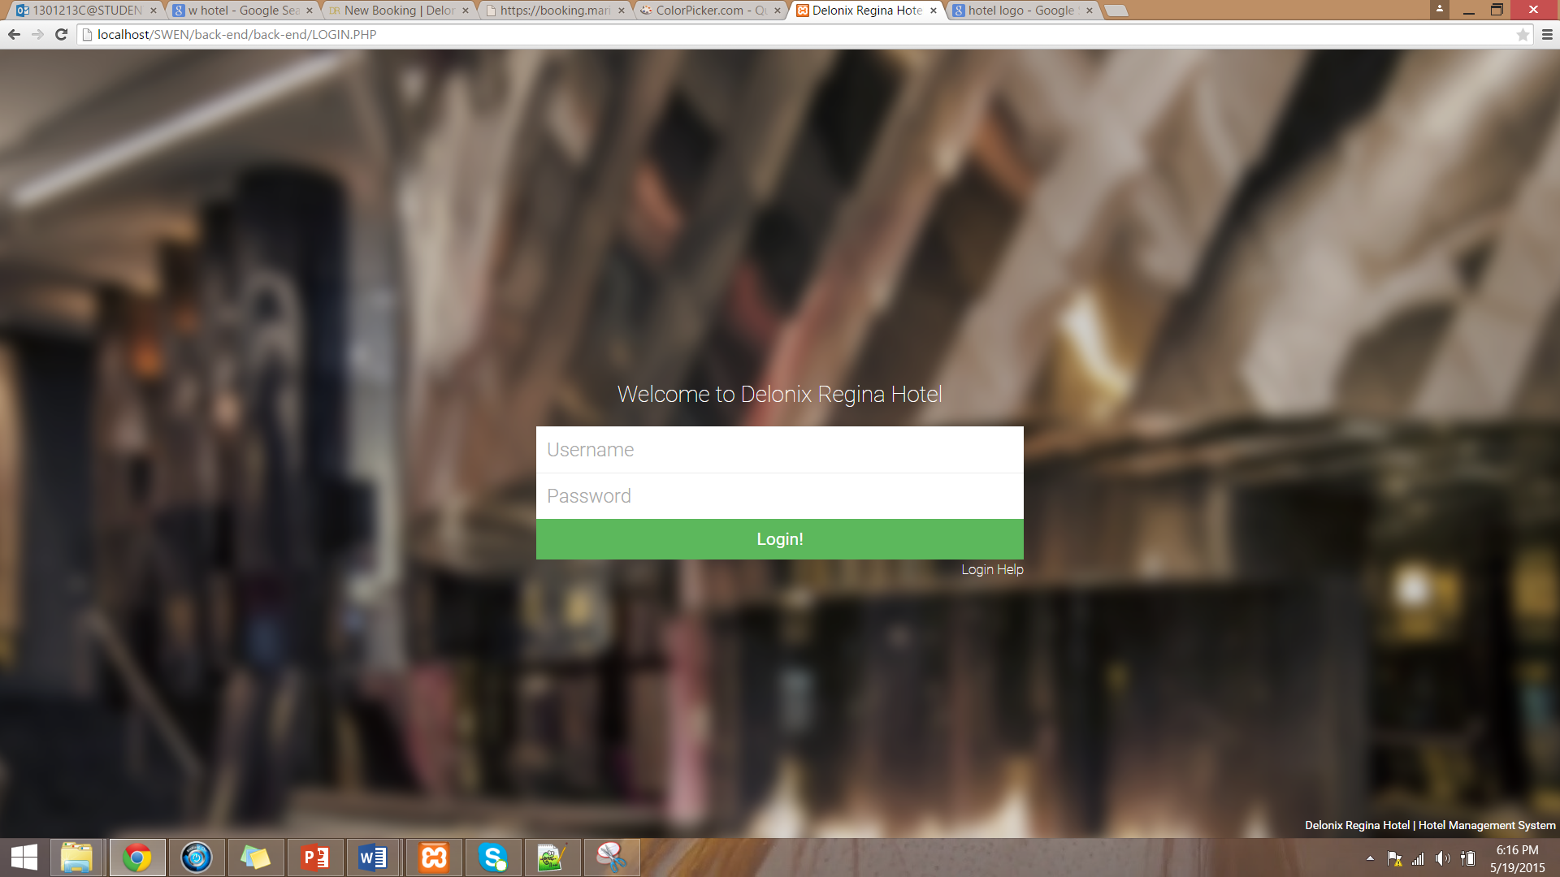

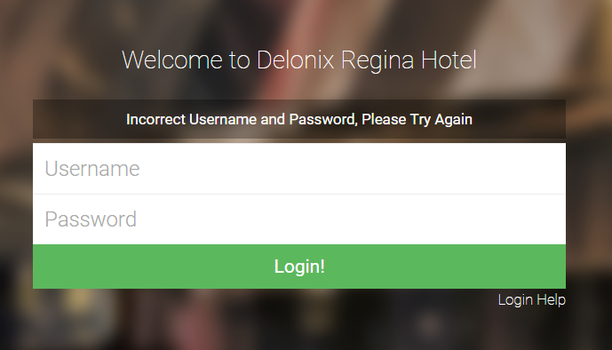

Booking Information

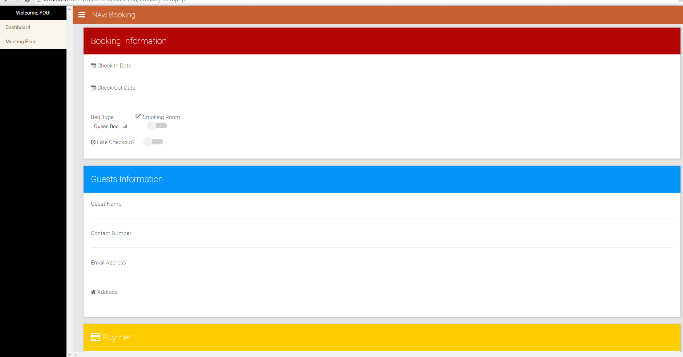

Staff Management List

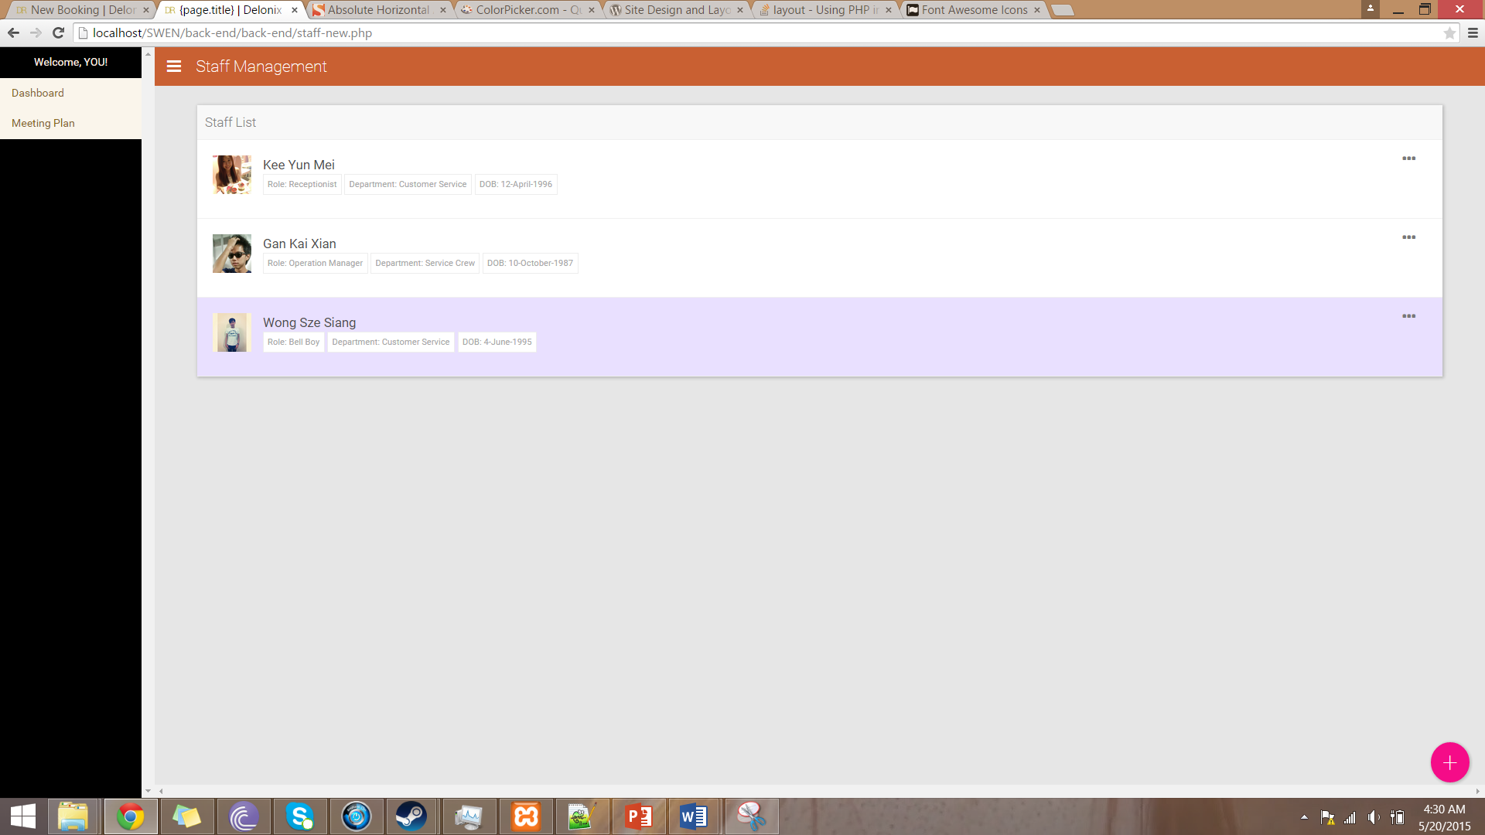

Interface with Other Systems
There will be no other system interfacing with our system as there was no system being implemented in the first place.

Assumptions
Before system implementation
- Payment can only be done manually before the system is being implement. Before implementation, payment transaction will happen when hotel guest checks out and many documents will be required.
- Data can be only input manually before the system is being implement. Before implementation, a hotel staff will be responsible to key in other staff data into the database.
- Smoking or Non-Smoking room cannot be chosen according to the customer preference.

After system implementation
- Payment can be done through the website. Transaction can be done via PayPal so everything will be mostly done without many documents.
- Data can now be input automatically after the system is being implemented. Any hotel staff who are authorized to do so will then be able to input and update data at any point of time when required.
- Smoking or Non-Smoking room can be chosen as according to the customer preference.

OPERATIONAL AND QUALITY REQUIREMENTS

Operating Environment
- The system which we will be deploying will be able to run on Windows XP environment. The system will be required to run on 24 by 7 but there will be a downtime occurring once a month which will be on first Sunday of every month from 0200 to 0400 so that there will be maintenance and also data backup at the same time.
The system has 3 main functions which are room availability and booking module, housekeeping and staff management module and reporting module.
The system can be used by 3 groups of personnel which are the end user, administrator for e.g. Mr and Mrs Wang, and management user. End user will be allow to make booking or advance booking through the system and also amend their booking details if required. Administrator e.g. Mr and Mrs Wang will be entitled to oversee all operation. Management user will be responsible for housekeeping job.

Development Constraints
- We may have used different versions of the software that can result in compilation error when we are compiling. That can cause us to delay the due date to either change our parts or solve the compilation error which can cause us to do double job like rechecking for errors.
- While developing the system, there could be major and minor bugs and errors occurring that could cause us to spend time in fixing those issues.
- The files could be corrupted or infected with viruses due to several reasons. This can cause the whole developed program to be unworkable and have to redevelop it from scratch.
- The time taken for the completion of each milestone of the system could be different. With each of us taking one part, we may have to wait for the others to complete their part before we can connect it together and then start on the next part.
- With some unforeseen circumstances, there could be a change of work due date like extending or shortening the due date required for the system. This can cause us to lose our pace and have a higher chance of causing an error. Example like this would be public holidays and leaves taken by us.
- As an intern, we only learned things taught by the school and that limits us to have limited knowledge of programming language like C# & Java Language. This can cause some problems as the programs may need other programming languages to complete the system.
- With the different working hours due to some personal reasons like traffic congestion, leaving earlier and etc., the time taken to complete the work could be unsynchronized and not according to the schedule.
The above mentioned constraints are not limited to other unexpected constraints such as resources failure or team members falling ill and more.

Performance
- Room Availability and Booking Module
  - Create
During the non-peak period the system response time would be 2 seconds. Whereas, around 11am to 12 noon which is the peak hours would take around 5 seconds for the system response time. There would be many people trying to access and book at this timing which can cause the website to slow down as data would have to be retrieve from the database. Should there be a same room booking at the same timing, both of the bookings would fail and they would have to book again.
  - Retrieve
The retrieval of data would not happen at the same time. If retrieval of data were to occur, it would happen simultaneously, which is why it would take a longer response time like around 5seconds during peak hours unlike the normal 2seconds timing.
  - Update
The update would take a normal of 2 seconds during non-peak period. If customers were to update their data or their requirements during 11am to 12 noon which is the peak hours, they would have to take a longer time since the system would have to extract even more data simultaneously.
  - Delete
The cancelation of bookings is the same with updating that would take a normal of 2 seconds during non-peak period. If customers were to cancel their bookings during 11am to 12 noon which is the peak hours, they would have to take a longer time since the system would have to extract even more data simultaneously.

- Housekeeping and Staff Management Module
  - Create
Only the Housekeeping Team Leader is able to plan out the schedule for the staff to do their duties before gaining the Staff Manager’s approval. The system response time would also be 1seconds since only the Team Leader are creating new schedule planning.
  - Retrieve
Since all are able to retrieve the data to check their own schedule, they would most probably do it during their break time. That would be around 3pm to 5pm and 10pm to 11pm. This period would take a longer system response time of around 3seconds instead of 1second for non-peak hours.

  - Update
The update will take around 1 second since it is only accessible to Team Leader, Staff Manager and Mr Wang. There would be no peak hour when updating the schedule.
  - Delete
The delete is the same as update which will take around 1 second since it is only accessible to Team Leader, Staff Manager and Mr Wang. There would be no peak hour when deleting the schedule.

- Reporting Module
  - Create
The system response time taken for creating a reporting module would take around 2 seconds. Only the Management team able to upload new reports. While Mr Wang is able to access to it using an administrators account. There would be no peak hours in using it since it is only used once a month to update reports of the hotel.
  - Retrieve
The retrieval of data would be around 2 seconds. Should Mr Wang and the Management Team are extracting the data the same time, it will extract simultaneously which can take around 3 seconds.
  - Update
The updating of reports would take 1 second as only the Management team would handle it. There would be no peak hours in updating of report.
  - Delete
The deleting of reports is unavailable to prevent misusing of important data.

- Login Creation Module
  - Create
The creating of staff records would take around 1 second. Since only Mr Wang is able to create a new record for staff, there would not be any peak hours for creating of new records.
  - Retrieve
Only the Housekeeping and Staff Management Team and Mr Wang is able to retrieve the data. The Housekeeping and Staff Management Team would use this to retrieve staffs’ data and use that to plan schedule. So the retrieval of data would take 1 second with no peak hours happening.
  - Update
Mr Wang and the Housekeeping and Staff Management Team would be able to update staffs’ particulars or their records in in the company. Hence, the updating will only take 2 seconds to complete.

  - Delete
Mr Wang is the only one able to delete the staffs’ record with the company. Thus, there would be no peak hours and it only takes 2 seconds to complete.

Availability
To ensure that Delonix Regia can attract more customers, the system will be required to run 24Hours per day, so as to cater to countries that have different international timing. The staff and Management Team that are doing overtime would be able to use the system to get their job done.

For the customers and staffs to have a better experience in using the system there would be a 2 hours downtime occurring for minor maintenance and data backups for the system every first Sunday of every month. It would happen in early morning 0200 to 0400 where most of the guests would be asleep and the staffs would have already knocked off from work.

In case of any emergency situations that require immediate attention, the problem would be resolved in at least 2 hours. Since there are minor maintenance every month, that would minimize the percentage of problems occurring frequently and get resolved in a faster time. The backups every month also ensures that the data would not be lost and is able to retrieve back if there was any need to erase the data on the system while fixing the problems.

Security and Access Control Requirements
- End Users
  - Customers
There would be two end users using the system where one of them is the customers and another one would be the receptionists. The customers would be able to use the Room Availability and Booking module to create a booking and they are only able to access to their own booking records with a unique code that would only be emailed to them after a successful booking. With the unique code that they received, they would be able to retrieve their data and would be able to update or delete their bookings. They are only restricted to having access to their own bookings by using the unique code sent to them.

- Receptionists
The receptionist would have their own authentication username and password. After logging into the system, they would have full access to the room availability and booking that can allow them to retrieve guests’ data so as to better assist them. By having full access, they are able to update or cancel the guests’ bookings in case the guests called up instead of doing it by themselves. They are also accessible to part of the reporting module so that they can update some data regarding the rooms’ availability and the number of rooms available into the report.

- Management Users
The Management users would be able to access to Room Availability and Booking Module, Housekeeping and Staff Management Module and the Reporting Module with their staff identification and password. The Management team would be able to use the Room Availability and Booking Module to take note of the availability of the rooms. Then they can use the Housekeeping and Staff Management Module to plan the number of manpower for each respective day. This can ensure the guests having an enjoyable and welcoming stay. The staffs would also not find it straining to work with shortage of manpower and will find the working environment to be enjoyable.

The Reporting Module allows the Management Users to create reports that are to be shown to Mr Wang. They are able to extract data from the different modules and use those data to create a report with the Reporting Module. They can also gain access to previously made reports and use it to compare with recent reports so that they can monitor the hotel’s business.

- Administrator
Mr Wang as the administrator of the whole hotel would be able to gain access to all the Modules with his sole username and password. His account would be a master key to all the functions of the hotel. As an administrator, he can oversee the whole operation of the hotel and if there are any amendments to be made, he can either do it himself or inform the respective staffs to do it. But example of creating and deleting of a staff account is only available Mr Wang. Not only can he oversee the modules, but he is also able to view the guests’ account.

SPECIAL REQUIREMENTS

- If there is any problem that occurs in the system then it will take approximately at least 2 hours or more to solve the problem.
- Data will be backup at least once a month during maintenance period.
- Security Codes will be given to customers that have booked the period of their stay so that the system is able to identify the customer.

REFERENCES

No reference was being used.

